STUDENT ASSISTANT POSITION

Employer/Dept: Employer/Department/School Name

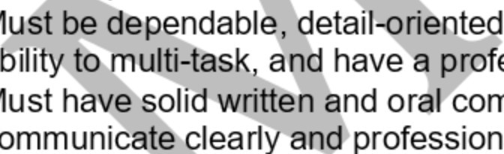Supervisor: Elizabeth Taylor, Finance & Accounting Professional

n h
o

Job Title: Student Assistant

Job Location/
Address: This position exists at two campuses: CU Denver in dow utz Medical Campus in Aurora. There is no travel required f ill select a single campus location when applying.

o m

Position Purpose: The Student Assistant assists financial aid
communications duties related to student e ining is provided both in person and via web trainin ndidates must be eligible to receive work-study
g a

a
p
e r duties as assigned

Job Description: This position is responsible fo ta entry, communications, recording/u staff with special
projects, general office and cl .

M M

Eligibility Requirements:

CU Denver student.
te, including Outlook, Excel, and Word
M
b e
M
o
, flexible, organized, willing to learn, possess the
a ssional demeanor.
mmunication skills, including the ability to
c ally via telephone and email.

e wards as part of the

Length of
Employment: student is enrolled at least half-time and ir financial aid award package.
o k

r

Remar mmits to showing up for work diligently and punctually, honesty, s, following directions, taking initiative, reliability, confidentiality,
ghness and accuracy with attention to detail, and interest in learning ndatory computer skills. Ideal candidates will be willing to work up
s weekly.
a a

Pay R - $13.00 per hour.

Applic
Process: Send a cover letter and resume to ourdepartment@ucdenver.edu or through CU Denver Handshake at https://ucdenver.joinhandshake.com/login.

Fax form to: 303-352-3554
Denver: Student Commons Building | PO Box 173364 | Campus Box 125 | Denver, CO 80217 | 303.315.1850 | Financialaid@ucdenver.edu Anschutz Medical Campus: Education 2 North | 13120 E. 19th Ave | Box A088 | Aurora, CO 80045 | 303.724.8039 | Financial.Aid@ucdenver.edu

