
Information Strategy and Services

DUO Login Change 2026
Table of Contents
New Visual Experience 1
Login Experience as of April 2026 1

New Experience as of April 2026
  - Logging into a Secure Resource
DUO is the tool used for Multi-Factor Authentication (MFA) across the university. The application has been updated to a newer version with enhanced security, which has resulted in some changes to the verification experience when using DUO for MFA.

Initial Login with DUO
  - New Experience for First Use
Still have questions? Contact the Service Desk: call 303.724.4357 (4-HELP from a campus phone) or open a ticket at servicecenter.oit.ucdenver.edu/CherwellPortal.
Updated on: DATE

Cre

Access the desired secure resource as usual.

Step 1: Login with your university credentials when prompted.
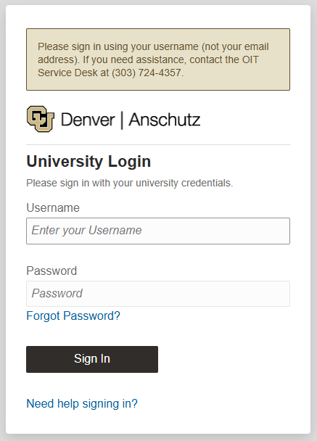

Step 2: After entering your credentials, you will be directed to a DUO screen with your username in the upper left corner prompting you to “Verify” that you are logging in.
Click the black “Verify” button to proceed if your username and log in attempt match.
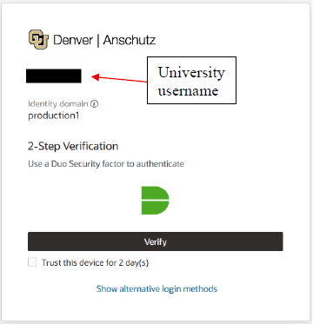

Step 3: The DUO authentication screen loads, select “Send Me a Push” and verify on your connected device. It will have your username in the upper left corner to confirm your attempt.

Note: Push verification is the most secure method of MFA verification as calls and passcodes are more susceptible to phishing.
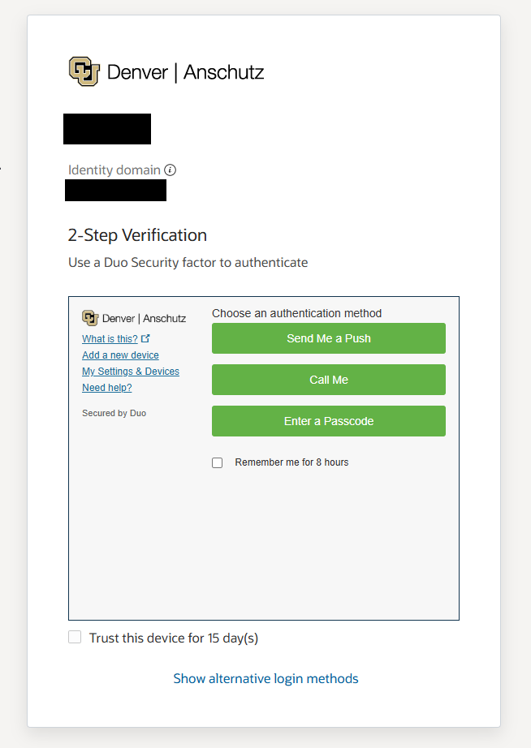
University username
Step 4: Check your device for your Push request. You will see a loading screen while you wait that has the device type and number the request was sent to for extra verification.

Note: Checking “Remember Me” will save these settings so that it will default to your preferred verification method for future login attempts and save you a click. This box is automatically checked so if you do not want it to default to this setting, pause here and uncheck it.

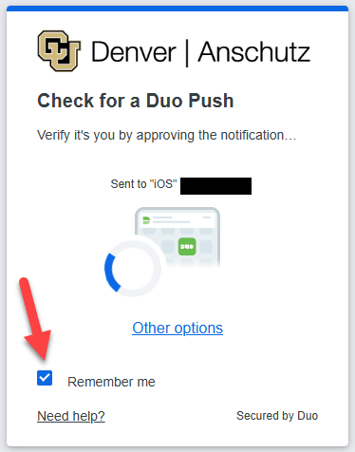

Step 5: Verify that the Push request on your device matches your location and request time; if it is you requesting, approve the Push and login to the secure university resource.

If you receive a Push verification request that does NOT match your location or attempt to access a secure resource, decline the Push and report the incident to the Service Desk.

Recurring Login with DUO
  - New Experience for MFA Prompts After First Use
Still have questions? Contact the Service Desk: call 303.724.4357 (4-HELP from a campus phone) or open a ticket at servicecenter.oit.ucdenver.edu/CherwellPortal.
Updated on: DATE

Cre

After you have chosen your verification option the first time you use DUO, the new application will remember this choice and default to it for future MFA requests.

Recurring MFA requests will follow this process:

Step 1: Access the secure resource and log in with your university credentials when prompted.

Step 2: After entering your credentials, you will be directed to a DUO screen with your username in the upper left corner prompting you to “Verify” that you are logging in.
Click the black “Verify” button to proceed if your username and log in attempt match.

NEW Step 3: Instead of being directed to the screen to choose “Send Me a Push,” “Call Me” or “Enter Passcode,” DUO remembers your device and will default to sending you a Push, getting you this loading screen:

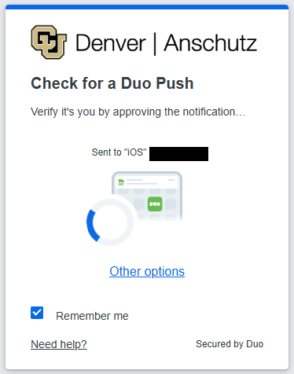

Step 4: Verify the Push on your device and proceed as usual.

Note: If the method DUO remembered was intended for one-time use or you want to change it, choose “Other options” and proceed to Step 5.
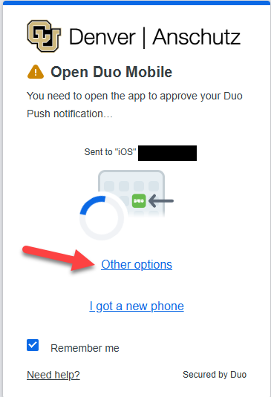

Step 5: After selecting “Other options,” you will be taken to a screen where you can choose a new verification method from a list of options.
